МИНИСТЕРСТВО ОБРАЗОВАНИЯ РЕСПУБЛИКИ БЕЛАРУСЬ

УЧРЕЖДЕНИЕ ОБРАЗОВАНИЯ

«БРЕСТСКИЙ ГОСУДАРСТВЕННЫЙ ТЕХНИЧЕСКИЙ УНИВЕРСИТЕТ»

ФАКУЛЬТЕТ ЭЛЕКТРОННО-ИНФОРМАЦИОННЫХ СИСТЕМ

Кафедра интеллектуальных информационных технологий

**Отчёт по лабораторной работе №5**

Специальность ПО11

Выполнил

Е. А. Германович

студент группы ПО11

Проверил

А. А. Крощенко

ст. преп. кафедры ИИТ,

12.04.2025 г.

Брест 2025

**Цель работы:** приобрести практические навыки разработки API и баз данных.

**Задание:**Общее задание

1. Реализовать базу данных из не менее 5 таблиц на заданную тематику.

При реализации продумать типизацию полей и внешние ключи в

таблицах;

2. Визуализировать разработанную БД с помощью схемы, на которой

отображены все таблицы и связи между ними (пример, схема на рис. 1);

3. На языке Python с использованием SQLAlchemy реализовать

подключение к БД;

4. Реализовать основные операции с данными (выборку, добавление,

удаление, модификацию);

5. Для каждой реализованной операции с использованием FastAPI

реализовать отдельный эндпойнт;

Базу данные можно реализовать в любой СУБД (MySQL, PostgreSQL, SQLite

и др.)

4) База данных Городской транспорт  
**Код программы:**

import os

from datetime import date, time

from typing import List

from fastapi import FastAPI, HTTPException, Depends

from sqlalchemy import (

Boolean,

Column,

Date,

Float,

ForeignKey,

Integer,

String,

Time,

create_engine,

)

from sqlalchemy.ext.declarative import declarative_base

from sqlalchemy.orm import relationship, sessionmaker

from pydantic import BaseModel

from typing import Optional

# Создание базы данных SQLite

DATABASE_URL = "sqlite:///./transport.db"

engine = create_engine(DATABASE_URL)

SessionLocal = sessionmaker(autocommit=False, autoflush=False, bind=engine)

Base = declarative_base()

# Модели SQLAlchemy

class Vehicle(Base):

__tablename__ = "vehicles"

id = Column(Integer, primary_key=True, index=True)

vehicle_number = Column(String(20), nullable=False)

model = Column(String(100), nullable=False)

capacity = Column(Integer, nullable=False)

year_of_manufacture = Column(Integer, nullable=False)

last_maintenance_date = Column(Date, nullable=True)

schedules = relationship("Schedule", back_populates="vehicle")

class Route(Base):

__tablename__ = "routes"

id = Column(Integer, primary_key=True, index=True)

route_number = Column(String(10), nullable=False)

start_point = Column(String(100), nullable=False)

end_point = Column(String(100), nullable=False)

distance_km = Column(Float, nullable=False)

estimated_time_minutes = Column(Integer, nullable=False)

schedules = relationship("Schedule", back_populates="route")

stops = relationship("Stop", secondary="route_stops", back_populates="routes")

class Driver(Base):

__tablename__ = "drivers"

id = Column(Integer, primary_key=True, index=True)

first_name = Column(String(50), nullable=False)

last_name = Column(String(50), nullable=False)

license_number = Column(String(20), nullable=False, unique=True)

experience_years = Column(Integer, nullable=False)

phone_number = Column(String(20), nullable=False)

schedules = relationship("Schedule", back_populates="driver")

class Schedule(Base):

__tablename__ = "schedules"

id = Column(Integer, primary_key=True, index=True)

route_id = Column(Integer, ForeignKey("routes.id"))

vehicle_id = Column(Integer, ForeignKey("vehicles.id"))

driver_id = Column(Integer, ForeignKey("drivers.id"))

is_weekend = Column(Boolean, default=False)

route = relationship("Route", back_populates="schedules")

vehicle = relationship("Vehicle", back_populates="schedules")

driver = relationship("Driver", back_populates="schedules")

class Stop(Base):

__tablename__ = "stops"

id = Column(Integer, primary_key=True, index=True)

name = Column(String(100), nullable=False)

address = Column(String(200), nullable=False)

latitude = Column(Float, nullable=False)

longitude = Column(Float, nullable=False)

routes = relationship("Route", secondary="route_stops", back_populates="stops")

class RouteStop(Base):

__tablename__ = "route_stops"

route_id = Column(Integer, ForeignKey("routes.id"), primary_key=True)

stop_id = Column(Integer, ForeignKey("stops.id"), primary_key=True)

stop_order = Column(Integer, nullable=False)

# Создание таблиц

Base.metadata.create_all(bind=engine)

app = FastAPI()

# Модели Pydantic для валидации данных

class VehicleBase(BaseModel):

vehicle_number: str

model: str

capacity: int

year_of_manufacture: int

last_maintenance_date: Optional[date] = None

class VehicleCreate(VehicleBase):

pass

class VehicleResponse(VehicleBase):

id: int

class Config:

from_attributes = True

class DriverBase(BaseModel):

first_name: str

last_name: str

license_number: str

experience_years: int

phone_number: str

class DriverCreate(DriverBase):

pass

class DriverResponse(DriverBase):

id: int

class Config:

from_attributes = True

class RouteBase(BaseModel):

route_number: str

start_point: str

end_point: str

distance_km: float

estimated_time_minutes: int

class RouteCreate(RouteBase):

pass

class RouteResponse(RouteBase):

id: int

class Config:

from_attributes = True

class StopBase(BaseModel):

name: str

address: str

latitude: float

longitude: float

class StopCreate(StopBase):

pass

class StopResponse(StopBase):

id: int

class Config:

from_attributes = True

class ScheduleBase(BaseModel):

route_id: int

vehicle_id: int

driver_id: int

is_weekend: bool = False

class ScheduleCreate(ScheduleBase):

pass

class ScheduleResponse(ScheduleBase):

id: int

class Config:

from_attributes = True

# Вспомогательная функция для получения сессии базы данных

def get_db():

db = SessionLocal()

try:

yield db

finally:

db.close()

# Эндпоинты для Vehicle

@app.post("/vehicles/", response_model=VehicleResponse)

def create_vehicle(vehicle: VehicleCreate, db: SessionLocal = Depends(get_db)):

db_vehicle = Vehicle(

vehicle_number=vehicle.vehicle_number,

model=vehicle.model,

capacity=vehicle.capacity,

year_of_manufacture=vehicle.year_of_manufacture,

last_maintenance_date=vehicle.last_maintenance_date

)

db.add(db_vehicle)

db.commit()

db.refresh(db_vehicle)

return db_vehicle

@app.get("/vehicles/", response_model=List[VehicleResponse])

def get_vehicles(db: SessionLocal = Depends(get_db)):

return db.query(Vehicle).all()

@app.get("/vehicles/{vehicle_id}", response_model=VehicleResponse)

def get_vehicle(vehicle_id: int, db: SessionLocal = Depends(get_db)):

vehicle = db.query(Vehicle).filter(Vehicle.id == vehicle_id).first()

if vehicle is None:

raise HTTPException(status_code=404, detail="Vehicle not found")

return vehicle

@app.put("/vehicles/{vehicle_id}", response_model=VehicleResponse)

def update_vehicle(vehicle_id: int, vehicle: VehicleCreate, db: SessionLocal = Depends(get_db)):

db_vehicle = db.query(Vehicle).filter(Vehicle.id == vehicle_id).first()

if db_vehicle is None:

raise HTTPException(status_code=404, detail="Vehicle not found")

db_vehicle.vehicle_number = vehicle.vehicle_number

db_vehicle.model = vehicle.model

db_vehicle.capacity = vehicle.capacity

db_vehicle.year_of_manufacture = vehicle.year_of_manufacture

db_vehicle.last_maintenance_date = vehicle.last_maintenance_date

db.commit()

return db_vehicle

@app.delete("/vehicles/{vehicle_id}")

def delete_vehicle(vehicle_id: int, db: SessionLocal = Depends(get_db)):

vehicle = db.query(Vehicle).filter(Vehicle.id == vehicle_id).first()

if vehicle is None:

raise HTTPException(status_code=404, detail="Vehicle not found")

db.delete(vehicle)

db.commit()

return {"message": "Vehicle deleted"}

# Эндпоинты для Route

@app.post("/routes/")

def create_route(route: dict):

db = SessionLocal()

db_route = Route(**route)

db.add(db_route)

db.commit()

db.refresh(db_route)

return db_route

@app.get("/routes/")

def get_routes():

db = SessionLocal()

return db.query(Route).all()

@app.get("/routes/{route_id}")

def get_route(route_id: int):

db = SessionLocal()

route = db.query(Route).filter(Route.id == route_id).first()

if route is None:

raise HTTPException(status_code=404, detail="Route not found")

return route

@app.put("/routes/{route_id}")

def update_route(route_id: int, route: dict):

db = SessionLocal()

db_route = db.query(Route).filter(Route.id == route_id).first()

if db_route is None:

raise HTTPException(status_code=404, detail="Route not found")

for key, value in route.items():

setattr(db_route, key, value)

db.commit()

return db_route

@app.delete("/routes/{route_id}")

def delete_route(route_id: int):

db = SessionLocal()

route = db.query(Route).filter(Route.id == route_id).first()

if route is None:

raise HTTPException(status_code=404, detail="Route not found")

db.delete(route)

db.commit()

return {"message": "Route deleted"}

# Эндпоинты для Driver

@app.post("/drivers/")

def create_driver(driver: dict):

db = SessionLocal()

db_driver = Driver(**driver)

db.add(db_driver)

db.commit()

db.refresh(db_driver)

return db_driver

@app.get("/drivers/")

def get_drivers():

db = SessionLocal()

return db.query(Driver).all()

@app.get("/drivers/{driver_id}")

def get_driver(driver_id: int):

db = SessionLocal()

driver = db.query(Driver).filter(Driver.id == driver_id).first()

if driver is None:

raise HTTPException(status_code=404, detail="Driver not found")

return driver

@app.put("/drivers/{driver_id}")

def update_driver(driver_id: int, driver: dict):

db = SessionLocal()

db_driver = db.query(Driver).filter(Driver.id == driver_id).first()

if db_driver is None:

raise HTTPException(status_code=404, detail="Driver not found")

for key, value in driver.items():

setattr(db_driver, key, value)

db.commit()

return db_driver

@app.delete("/drivers/{driver_id}")

def delete_driver(driver_id: int):

db = SessionLocal()

driver = db.query(Driver).filter(Driver.id == driver_id).first()

if driver is None:

raise HTTPException(status_code=404, detail="Driver not found")

db.delete(driver)

db.commit()

return {"message": "Driver deleted"}

# Эндпоинты для Schedule

@app.post("/schedules/", response_model=ScheduleResponse)

def create_schedule(schedule: ScheduleCreate, db: SessionLocal = Depends(get_db)):

db_schedule = Schedule(

route_id=schedule.route_id,

vehicle_id=schedule.vehicle_id,

driver_id=schedule.driver_id,

is_weekend=schedule.is_weekend

)

db.add(db_schedule)

db.commit()

db.refresh(db_schedule)

return db_schedule

@app.get("/schedules/", response_model=List[ScheduleResponse])

def get_schedules(db: SessionLocal = Depends(get_db)):

return db.query(Schedule).all()

@app.get("/schedules/{schedule_id}", response_model=ScheduleResponse)

def get_schedule(schedule_id: int, db: SessionLocal = Depends(get_db)):

schedule = db.query(Schedule).filter(Schedule.id == schedule_id).first()

if schedule is None:

raise HTTPException(status_code=404, detail="Schedule not found")

return schedule

@app.put("/schedules/{schedule_id}", response_model=ScheduleResponse)

def update_schedule(schedule_id: int, schedule: ScheduleCreate, db: SessionLocal = Depends(get_db)):

db_schedule = db.query(Schedule).filter(Schedule.id == schedule_id).first()

if db_schedule is None:

raise HTTPException(status_code=404, detail="Schedule not found")

db_schedule.route_id = schedule.route_id

db_schedule.vehicle_id = schedule.vehicle_id

db_schedule.driver_id = schedule.driver_id

db_schedule.is_weekend = schedule.is_weekend

db.commit()

return db_schedule

@app.delete("/schedules/{schedule_id}")

def delete_schedule(schedule_id: int, db: SessionLocal = Depends(get_db)):

schedule = db.query(Schedule).filter(Schedule.id == schedule_id).first()

if schedule is None:

raise HTTPException(status_code=404, detail="Schedule not found")

db.delete(schedule)

db.commit()

return {"message": "Schedule deleted"}

# Эндпоинты для Stop

@app.post("/stops/")

def create_stop(stop: dict):

db = SessionLocal()

db_stop = Stop(**stop)

db.add(db_stop)

db.commit()

db.refresh(db_stop)

return db_stop

@app.get("/stops/")

def get_stops():

db = SessionLocal()

return db.query(Stop).all()

@app.get("/stops/{stop_id}")

def get_stop(stop_id: int):

db = SessionLocal()

stop = db.query(Stop).filter(Stop.id == stop_id).first()

if stop is None:

raise HTTPException(status_code=404, detail="Stop not found")

return stop

@app.put("/stops/{stop_id}")

def update_stop(stop_id: int, stop: dict):

db = SessionLocal()

db_stop = db.query(Stop).filter(Stop.id == stop_id).first()

if db_stop is None:

raise HTTPException(status_code=404, detail="Stop not found")

for key, value in stop.items():

setattr(db_stop, key, value)

db.commit()

return db_stop

@app.delete("/stops/{stop_id}")

def delete_stop(stop_id: int):

db = SessionLocal()

stop = db.query(Stop).filter(Stop.id == stop_id).first()

if stop is None:

raise HTTPException(status_code=404, detail="Stop not found")

db.delete(stop)

db.commit()

return {"message": "Stop deleted"}

if __name__ == "__main__":

import uvicorn

uvicorn.run(app, host="0.0.0.0", port=8000)

**Рисунки с результатами работы программы:**

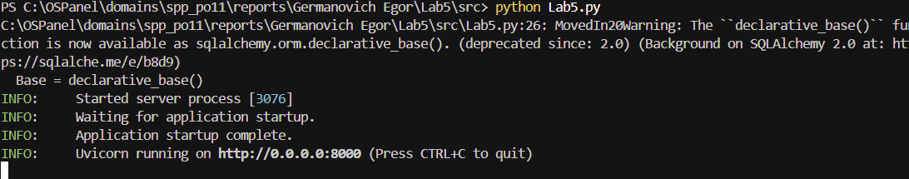

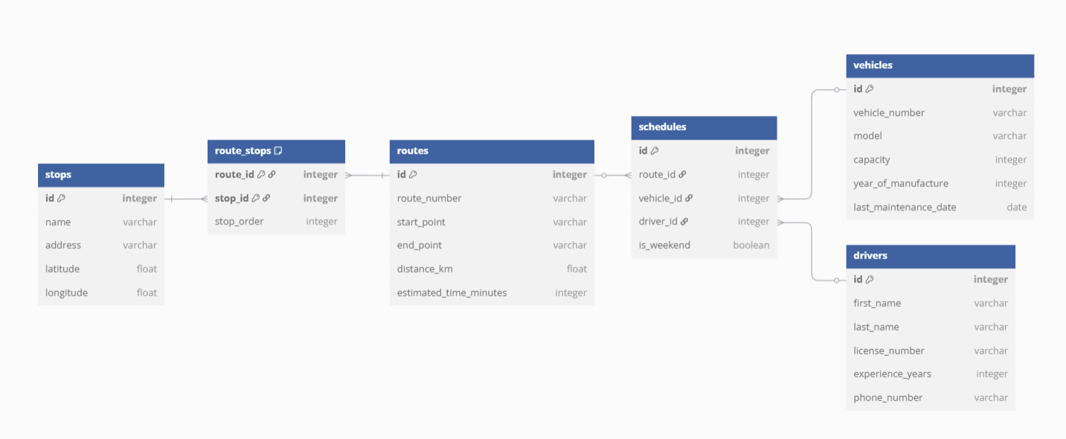

**Вывод:** приобрел практические навыки разработки API и баз данных.